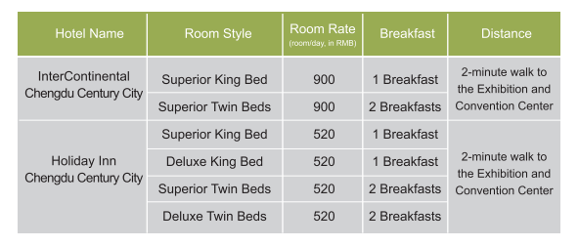

Hotel Booking Form
Corp:
Guest Name: |  | Mobile:
Hotel Name | Room Style | Quantity | Check-in | Check-out

Notes:
1. Please fill in the form and send back to the Organizing Committee by Email.
Contact: Mr. LIN Yuhong Cell Phone:86-185 0085 5651
E-mail: info@info-cma.org Fax: 86-10-6603 3686

2. Please do the check-in before 18:00.

